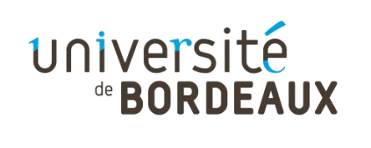
PERSONAL DATA COLLECTION FORM
The information collected with this form will be processed by the University of Bordeaux in order to create a directory for students, teachers and administrative staff. This directory will/may be used by university students in their search for international internships.
In accordance with the Data Protection Act of 6 January 1978 as amended, you have the right of access and rectification regarding your personal information.
You can access your information by contacting : stages.tec@u-bordeaux.fr
You may also, for legitimate reasons, object to the processing of your personal data.
For further information, consult your rights on the CNIL website : https://www.cnil.fr/en/home
Company Name: ………………………………………………………………………………………………………………………………..

Address: ……………………………………………………………………………………………………………………………………………

Surname and first name of the person to contact for any internship application :

……………………………………………………………………………………………………………………………………………………..

Position: ……………………………………………………………………………………………………………………………………..

E-mail: ……………………………………………………………………………………………………………………

Phone: …………………………………………………………………………………………………….

I accept that my contact details appear in the directory of companies likely to offer international internships to students of the University of Bordeaux.

I do not accept that my contact details appear in the directory of companies likely to offer international internships to students of the University of Bordeaux.

Please return this form to stages.tec@u-bordeaux.fr

